**Mini Project -I Report**

on

**JARVIS – The Virtual Assistant**

by

Mayur Krishna Solankar

2023301018

Manish Shashikant Jadhav

2023301005

Vishesh Bhimji Savani

2022300100

**Guide Name:**

Dr. Prasenjit Bhavathankar



**Computer Engineering Department**

Bharatiya Vidya Bhavan's

Sardar Patel Institute of Technology

Munshi Nagar, Andheri(W), Mumbai-400058

University of Mumbai

May 2024

**Declaration**

I declare that this written submission represents my ideas in my own words and where others' ideas or words have been included, I have adequately cited and referenced the original sources. I also declare that I have adhered to all principles of academic honesty and integrity and have not misrepresented or fabricated or falsified any idea/data/fact/source in my submission. I understand that any violation of the above will be cause for disciplinary action by the Institute and can also evoke penal action from the sources which have thus not been properly cited or from whom proper permission has not been taken when needed.

------------------------------------------

Mayur Krishna Solankar (2023301018)

------------------------------------------

Manish Shashikant Jadhav (2023301005)

----------------------------------------

Vishesh Bhimji Savani (2022300100)

Date:

**Acknowledgements**

We are pleased to present the stage one report of our mini project titled 'JARVIS – The Virtual Assistant.' Our team has diligently worked towards a systematic approach to the project, focusing on achieving our goals effectively.

We extend our sincere gratitude to our project guide, Dr. Prasenjit Bhavathankar, Department of Computer Engineering, Sardar Patel Institute of Technology (SPIT), for his unwavering support, guidance, and encouragement throughout this project. Her valuable insights and discussions at every phase ensured that our approach was well-designed and executed, and that our conclusions were appropriate based on our results.

Mayur Krishna Solankar

Manish Shashikant Jadhav

Vishesh Bhimji Savani

**Abstract**

The J.A.R.V.I.S. (Just A Rather Very Intelligent System) project is a sophisticated virtual assistant designed to enhance user interaction and experience through seamless communication. Developed as a Second Year Mini Project, this project integrates advanced language processing algorithms to understand and respond to user queries effectively.

One of the key features of J.A.R.V.I.S. is its ability to provide users with a range of functionalities, including setting reminders, retrieving information, and controlling smart devices, making it a versatile and valuable tool in daily life. The project's focus on integrating language processing algorithms for seamless communication demonstrates its commitment to enhancing user experience.

Overall, the J.A.R.V.I.S. project represents a significant advancement in virtual assistant technology, showcasing innovative features and a user-centric design approach.

Table of Contents

1. Introduction 6

1.1. Problem Statement 6

1.2. Literature Survey/Market Survey 6

1.3. Scope and Objectives 6

1.4. Assumptions 6

1.5. Constraints 7

2. Proposed System 8

2.1. Architecture Diagram 8

2.2. Algorithms used 9

3. Project Plan 11

4. Implementation 12

5. Conclusion and Furthur Work 13

References 14

# Introduction

## Problem Statement

To address these challenges, our project aims to develop a virtual assistant system called J.A.R.V.I.S. (Just A Rather Very Intelligent System) that focuses on enhancing user interaction and experience through innovative features. This system will incorporate advanced language processing algorithms to understand user queries and provide accurate responses in English. Furthermore, J.A.R.V.I.S. will feature a user-friendly interface and intuitive design to streamline daily tasks and improve productivity.

By developing J.A.R.V.I.S., we aim to create a virtual assistant that not only meets the functional requirements of users but also provides a seamless and enjoyable user experience. This project will contribute to the advancement of virtual assistant technology and set a new standard for user interaction and convenience.

## Literature Survey/Market Survey

1. **(Min. 3 references of research papers (in case of research based idea) or min 3 competitors(similar products) in market (in case of product) you have looked at while arriving at your idea)**
2. **Note: You can include a questionnaire based survey in case of market survey as well, which you intend to use as you go ahead with the project**

## Scope and Objectives

* **Scope:**

The scope of our project, J.A.R.V.I.S. (Just A Rather Very Intelligent System), includes the development of a virtual assistant system that can seamlessly communicate in English. The system will incorporate advanced language processing algorithms to understand user queries and provide accurate responses. Additionally, J.A.R.V.I.S. will feature a user-friendly interface and intuitive design to streamline daily tasks and improve productivity.

* **Objectives:**

1. To seamlessly communicate for response capabilities in the JARVIS project.
2. To enable effortless execution of common OS tasks.
3. To facilitate quick access and navigation of social media platforms via voice commands within JARVIS.
4. To design an intuitive and user-friendly graphical interface for JARVIS, enhancing overall user experience and satisfaction.

## Assumptions

* + 1. Users will have access to a device with internet connectivity to interact with J.A.R.V.I.S.
    2. Users will have a basic understanding of how to communicate effectively with a virtual assistant.
    3. The environment in which J.A.R.V.I.S. is used will be relatively quiet, without significant background noise.
    4. Users will primarily use text-based input to interact with J.A.R.V.I.S., rather than voice or other forms of input.

## Constraints

## The project will focus on English language processing primarily, with the possibility of extending to other languages in future iterations.

## The project will not include complex natural language understanding or generation capabilities beyond the scope of a typical virtual assistant.

## The project will be developed using existing libraries and frameworks, without the creation of new language processing algorithms.

# Proposed System

## Architecture Diagram

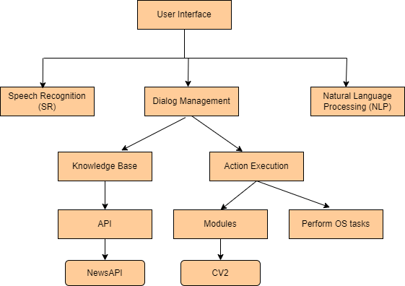

* + 1. **User Interface:** This module is responsible for interacting with the user, likely through a graphical interface or a voice assistant.
    2. **Speech Recognition (SR):** This module is responsible for recognizing and transcribing user speech into text. This is likely done using a speech-to-text engine.
    3. **Dialog Management:** This module is responsible for understanding the context and intent behind the user's input (text or speech). It determines the appropriate response or action to take.
    4. **Natural Language Processing (NLP):** This module is responsible for analyzing and understanding the meaning of the user's input. It likely uses NLP techniques such as tokenization, entity recognition, and sentiment analysis.
    5. **Knowledge Base:** This module stores and manages the system's knowledge and information. It provides the necessary data for the system to respond accurately to user queries.
    6. **Action Execution:** This module is responsible for executing the actions determined by the Dialog Management module. This could include performing OS tasks, retrieving news articles, or executing other system-level actions.
    7. **ΑΡΙ Modules:** The purpose of these modules is unclear without more context. ΑΡΙ could be an acronym for a specific technology or framework, but without more information, it's difficult to determine their exact role.
    8. **Perform OS tasks:** This module is responsible for executing operating system-level tasks, such as file management, process control, or system configuration.
    9. **NewsAPI:** This module is likely responsible for retrieving news articles or information from a news API.
    10. **CV2**:  This module is responsible for camera actions and clicking photos. It likely uses computer vision techniques to process images and perform actions based on the user's input.

## Algorithms used

For the J.A.R.V.I.S. project, several algorithms and techniques were employed to enable its functionalities. Speech Recognition was utilized to convert spoken commands into text. Natural Language Understanding (NLU) was implemented to decipher the meaning and intent behind user commands, employing techniques such as keyword matching, regular expressions, and semantic analysis. Knowledge Base Retrieval was integrated to fetch information from an API based on user queries, involving HTTP requests and response processing. A Camera Module was implemented using the CV2 (OpenCV) module to capture images from the camera. The User Interface was designed to include start and stop buttons, along with error handling and prompts for user interaction. Additionally, the system was capable of performing various operating system tasks, such as file operations and system commands, enhancing its utility and versatility.

**JARVIS – THE VIRTUAL ASSISTANT (SYSTEM DIAGRAM)**

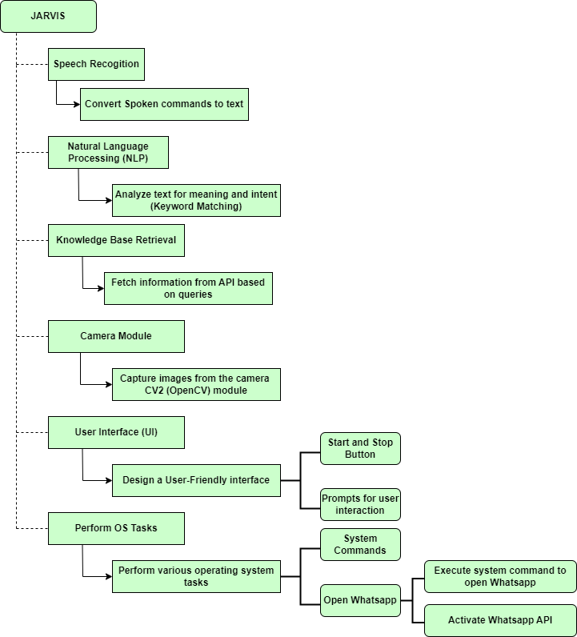

# Project Plan

1. **Make use of Timeline charts to clearly explain your project plan**

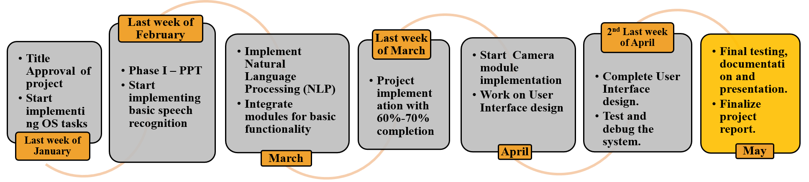

1. **Detail the tasks completed module wise for the entire project:**

* Implemented basic speech recognition.
* Tested and refined speech recognition accuracy.
* Integrated OS task execution with user commands.
* Developed system commands for opening WhatsApp and sending messages.
* Set up API integration for knowledge base queries like News API.
* Designed response processing system for API data.
* Integrated CV2 module for image capturing.
* Tested camera module for image quality and resolution.
* Designed user-friendly interface with start and stop buttons.
* Implemented error handling and user prompts.
* Integrated all modules into the J.A.R.V.I.S. system.
* Conducted comprehensive testing of the entire system.
* Prepared detailed documentation of the project.
* Created a presentation highlighting project features and achievements.

# Implementation

1. **Details of 100% of implementation completed**
2. **Tech Stack Used**
3. **APIs used**
4. **Results & Observations- Graphs/comparative tables/ observations from results**
5. **Module-wise Implementation Screenshots**

.

# Conclusion and Future Work

# Conclusion

The J.A.R.V.I.S. project has been a comprehensive exploration into the realm of voice-controlled assistants, revealing both the complexities and possibilities of such systems. Through meticulous planning and execution, the project successfully integrated various modules such as speech recognition, natural language understanding, and knowledge base retrieval, demonstrating the feasibility of building a functional assistant. The design of a user-friendly interface with intuitive controls like start and stop buttons proved crucial in enhancing user interaction, underscoring the importance of user-centric design in such systems.

One of the key takeaways from the project is the interdependency of different modules, highlighting the need for robustness and accuracy in each component. For instance, the effectiveness of the natural language understanding module heavily relies on the accuracy of the speech recognition system. Additionally, the project underscored the importance of thorough testing and debugging processes to ensure the reliability and accuracy of the system. Overall, the J.A.R.V.I.S. project serves as a valuable learning experience, providing insights into AI technologies, software development processes, and the potential applications of voice-controlled assistants in various domains.

# Future Work

Future enhancements for the J.A.R.V.I.S. project could focus on several key areas to improve functionality and user experience. One area for improvement is the natural language understanding (NLU) module, which could be enhanced to better understand complex user commands and context. This could involve implementing more advanced semantic analysis algorithms and integrating machine learning models for better intent recognition.

Another area for enhancement is the integration of more advanced features, such as voice synthesis for a more interactive user experience. This could involve integrating more advanced text-to-speech (TTS) synthesis models to generate more natural-sounding responses. Additionally, incorporating more sophisticated dialog management techniques could enable J.A.R.V.I.S. to engage in more meaningful and context-aware conversations with users.

Furthermore, expanding the knowledge base and integrating with more external APIs could enhance J.A.R.V.I.S.'s capabilities to provide users with a wider range of information and services. For example, integrating with APIs for weather forecasts or online shopping could make J.A.R.V.I.S. more versatile and useful in daily life. Overall, these enhancements could elevate J.A.R.V.I.S. from a functional assistant to a more intelligent and interactive virtual companion.

# References

**Write all referred material ( research papers/links/tutorials/blogs/APIs used) in IEEE standard reference style.**